Brætspilsliste
Indhold
Brætspilsliste 1
Twilight Imperium 4th Edition 3
Tanks – PANTHER vs SHERMAN starter set 3
Diplomacy 3
Mutant Chronicles – Kampen om forbandelsens borg 4
Exploding kittens – NSFW-edition 4
Imploding kittens 4
Aye, Dark Overlod – The Green Box 4
Mag*Blast 3rd Edition 5
Chez Goth 5
Flames of War 5
Say what!? 5
Gloom 2nd Edition 6
Secret Hitler 6
BANG! 6
Bohnanza 6
Munchkin 7
SPANC – Space Pirate Amazon Ninja Catgirls 7
A Game of Thrones – The Board Game 2nd Edition 7
Ringenes Herre 7
Wings of War – WWII Miniatures 8
Shadows over Camelot 8
Smallworld 8
JUNTA! 8
Level 7 – Omega Protocol 9
Skak 9
Chez Geek (kun kort) 9
Settlers fra Catan – Supplementsæt for 5 og 6 spillere 10
Betrayal at House on the Hill 2nd Edition 11
Betrayal at House on the Hill – Widow’s Walk 11
Kremlin 11
Blood Bowl Team Manager – The Card Game 11
Battlestar Galactica – The Board Game (spil i udvidelseskasserne) 13
Battlestar Galactica – Pegasus Expansion 13
Battlestar Galactica – Daybreak Expansion 13
Battlestar Galactica – Exodus Expansion 13
World of Warcraft – The Board Game 13
Backgammon 15
Star Wars Imperial Assault 15
Star Wars Imperial Assault – Return to Hoth 15
Star Wars Imperial Assault – Jabba’s Realm 15
Star Wars Imperial Assault – Heart of the Empire 16
Star Wars Imperial Assault – The Bespin Gambit 16
Star Wars Imperial Assault – Tyrants of Lothal 16

43 i alt

Twilight Imperium 4th Edition
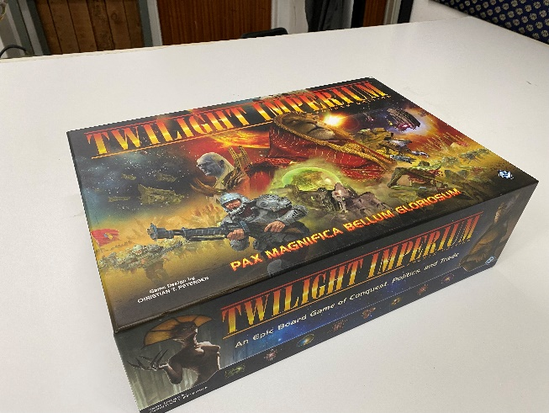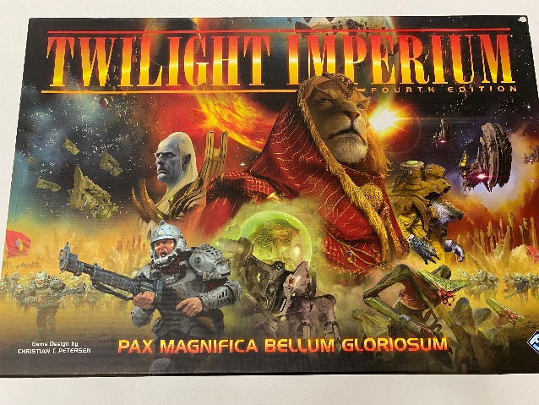

Tanks – PANTHER vs SHERMAN starter set
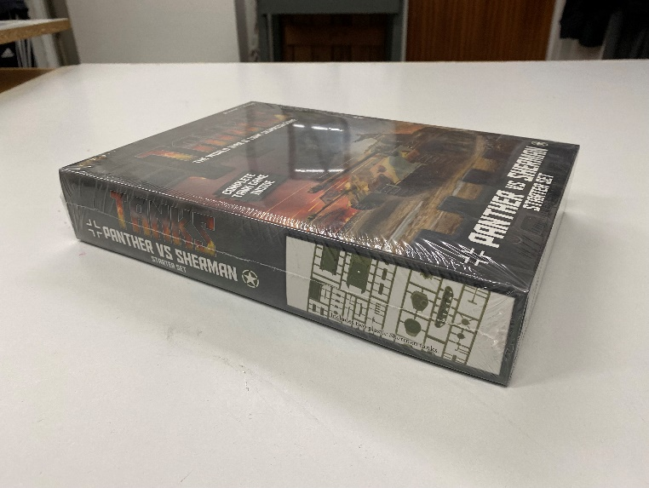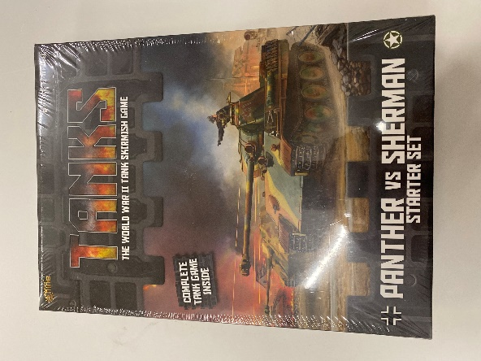

Diplomacy
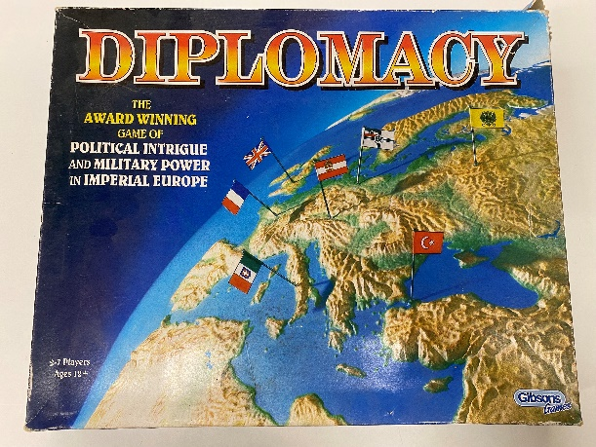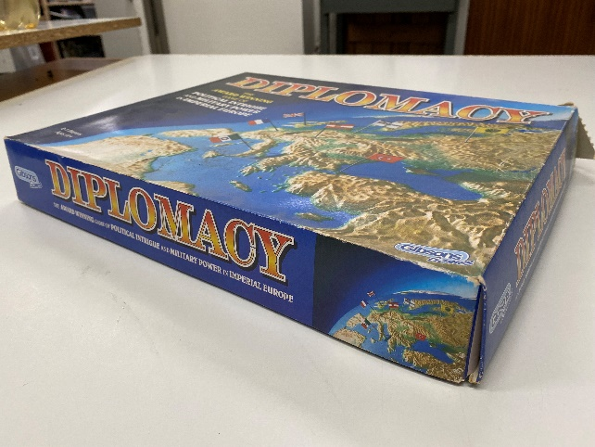

Mutant Chronicles – Kampen om forbandelsens borg
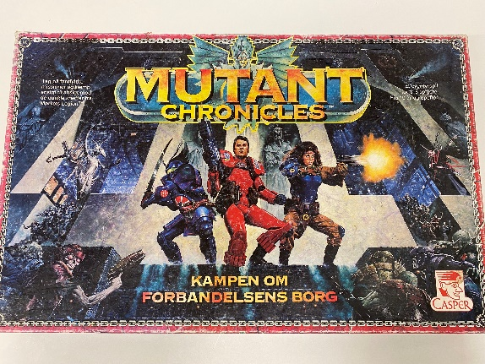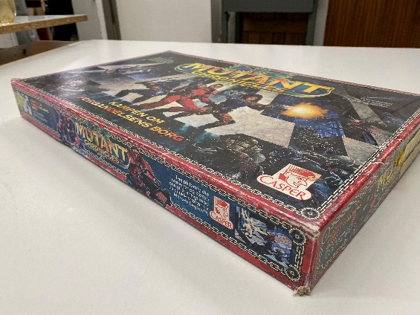

Exploding kittens – NSFW-edition
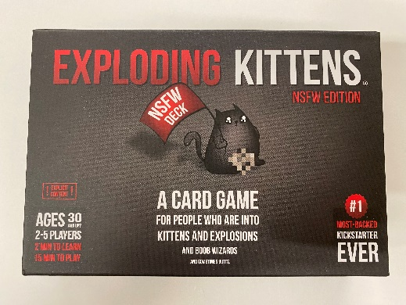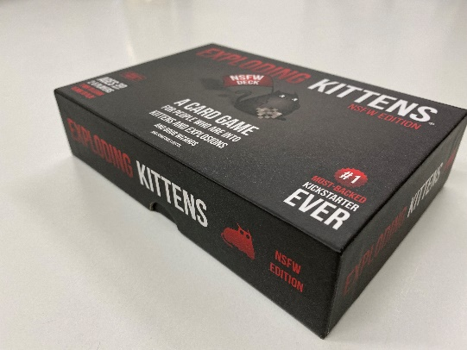

Imploding kittens
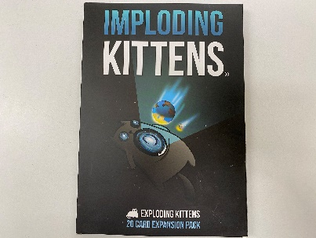

Aye, Dark Overlod – The Green Box
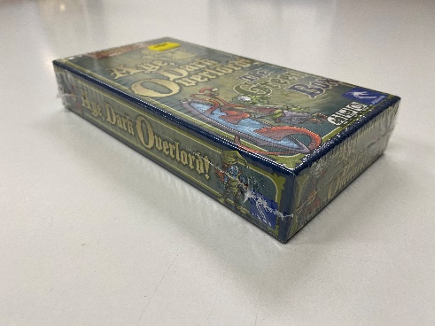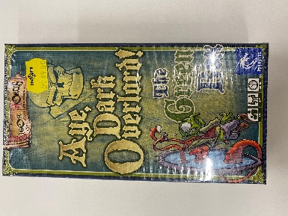

Mag*Blast 3rd Edition
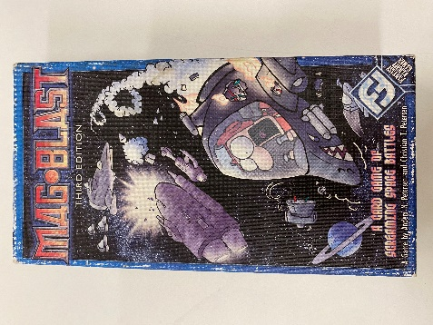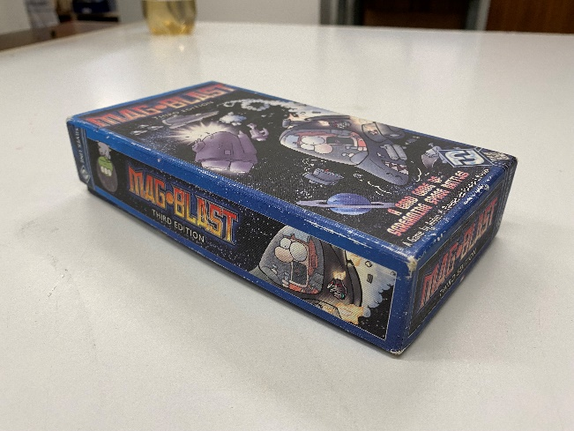

Chez Goth
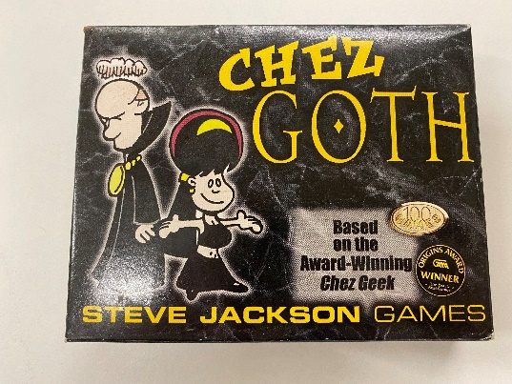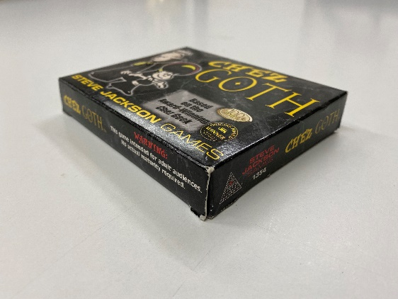

Flames of War
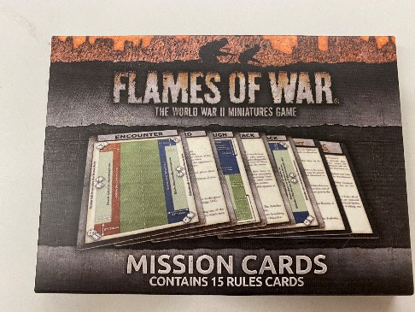

Say what!?
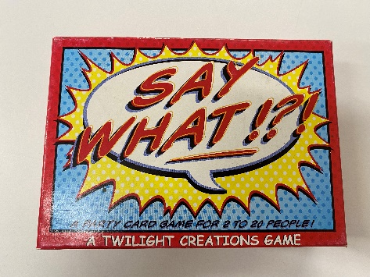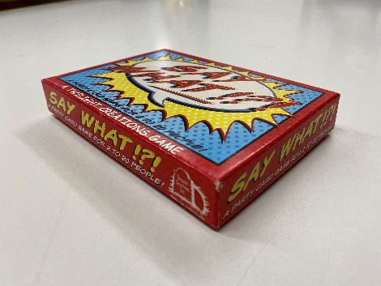

Gloom 2nd Edition
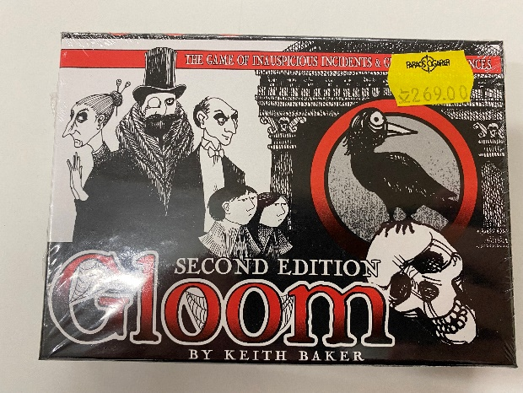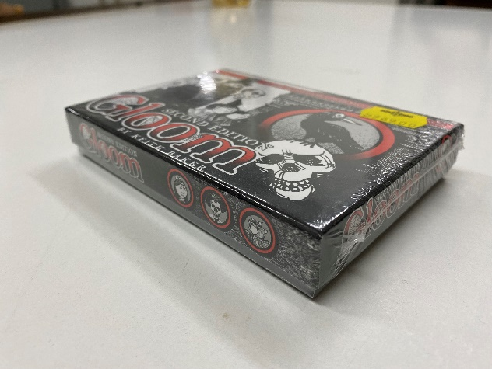

Secret Hitler
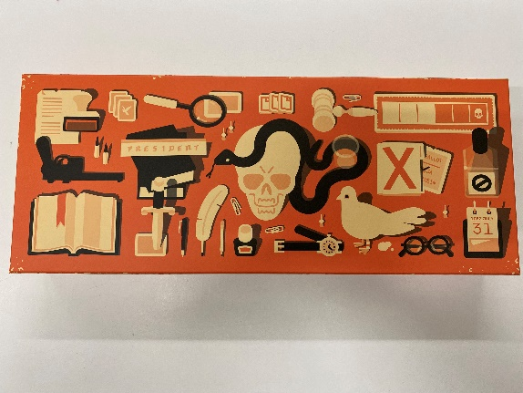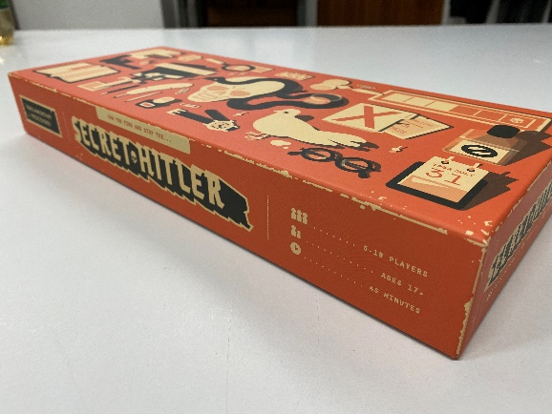

BANG!
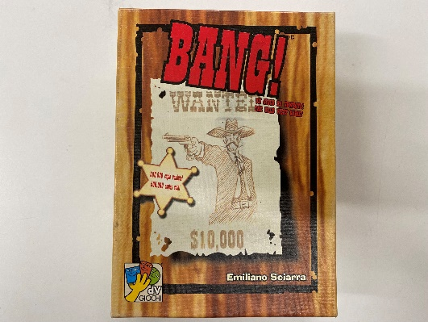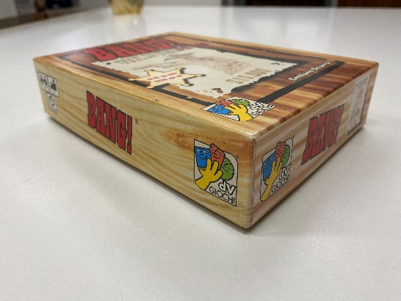

Bohnanza
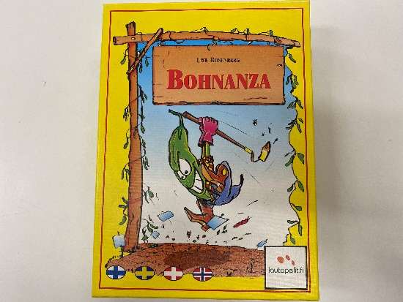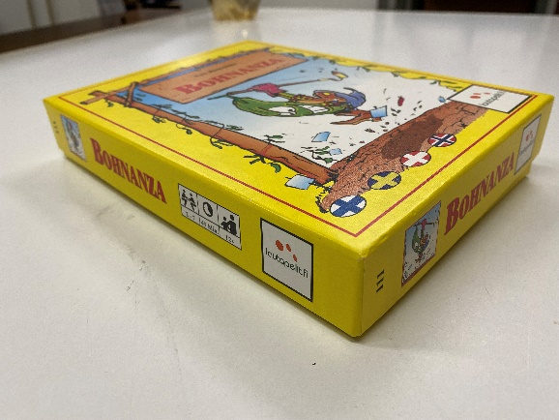

Munchkin
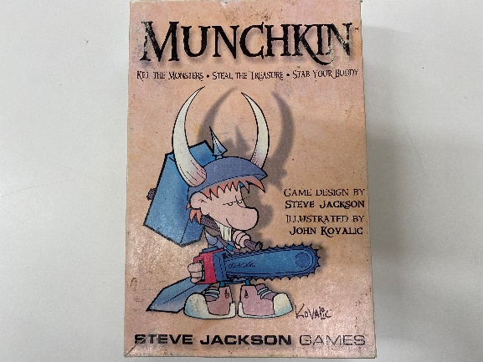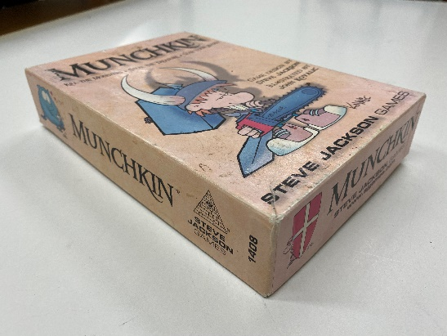

SPANC – Space Pirate Amazon Ninja Catgirls
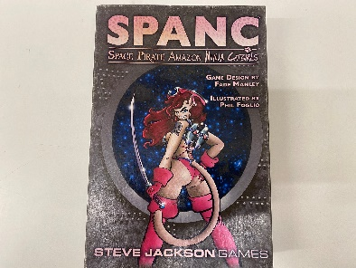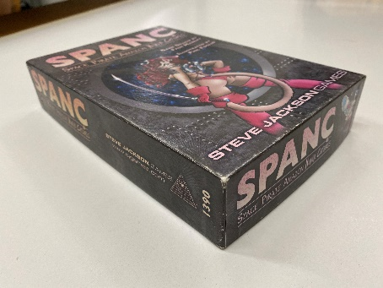

A Game of Thrones – The Board Game 2nd Edition
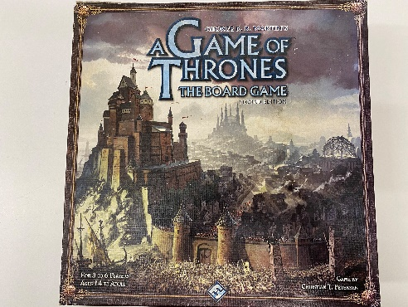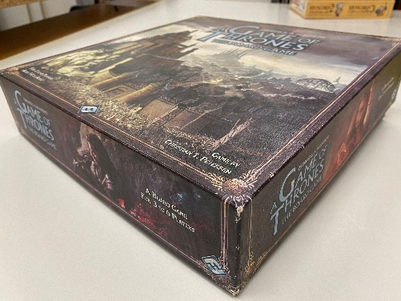

Ringenes Herre
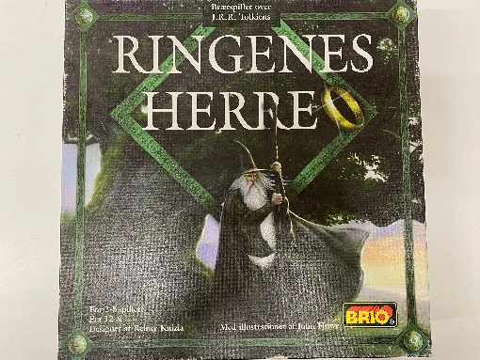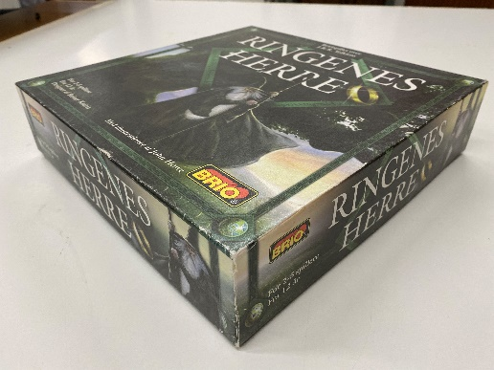

Wings of War – WWII Miniatures
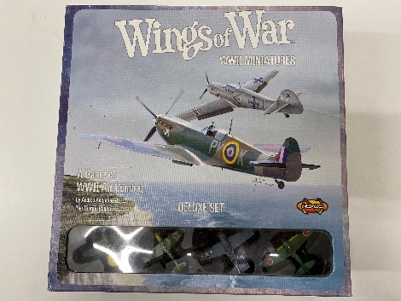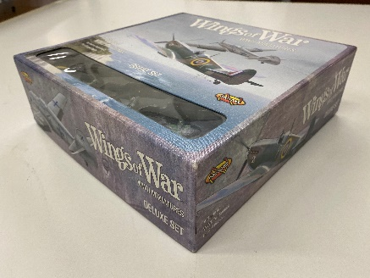

Shadows over Camelot
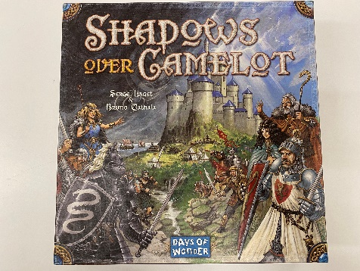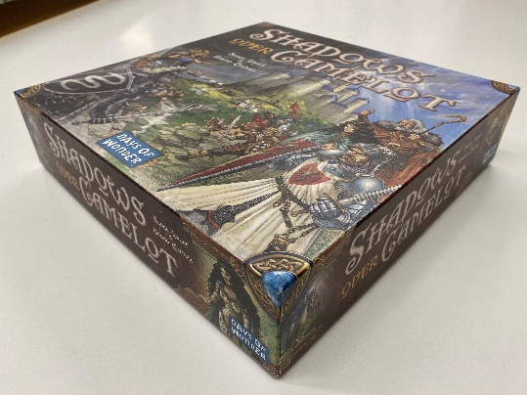

Smallworld
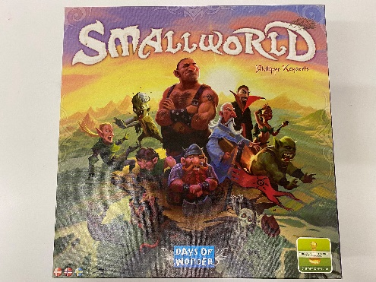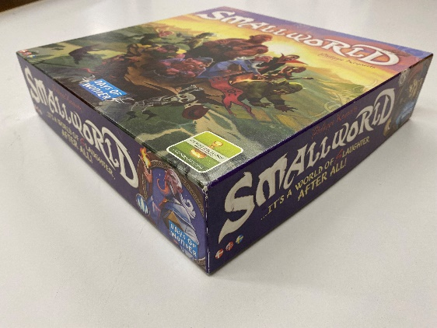

JUNTA!
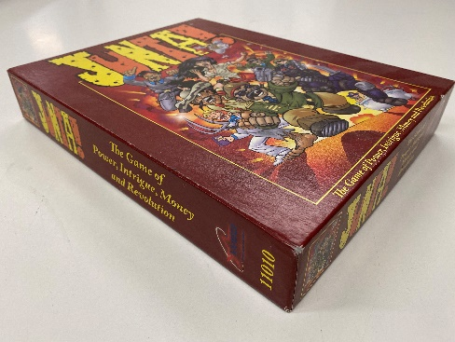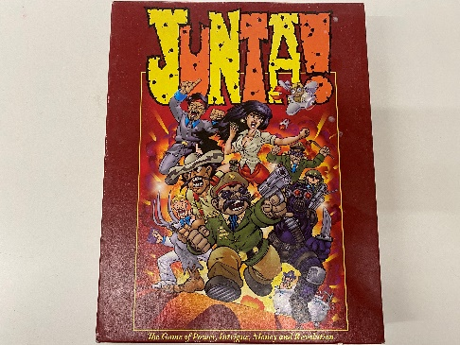

Level 7 – Omega Protocol
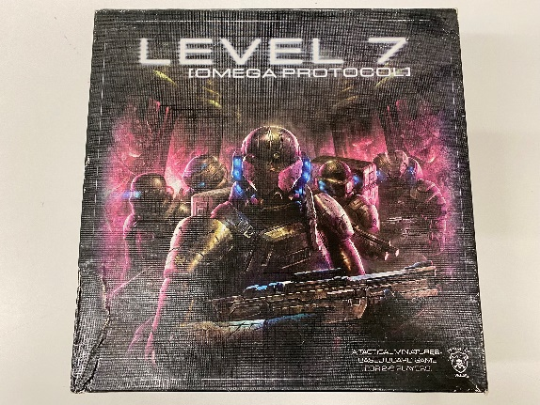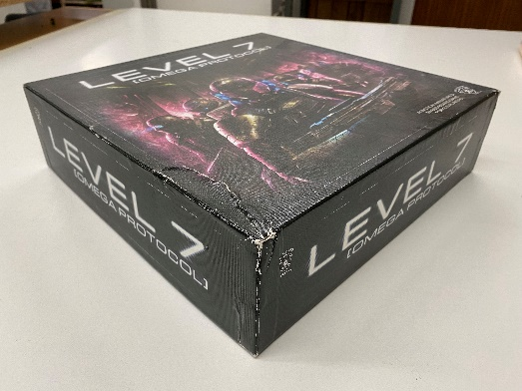

Skak
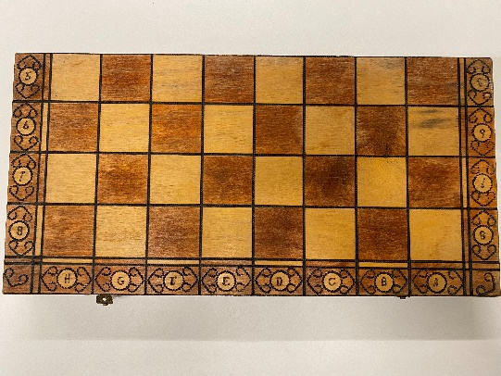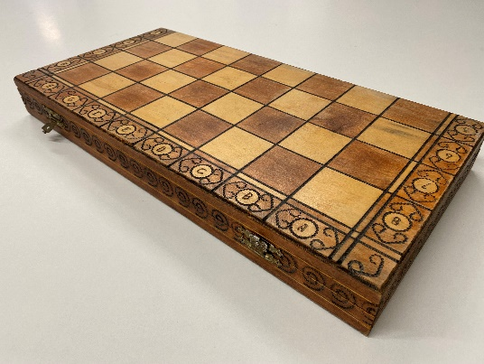

Chez Geek (kun kort)
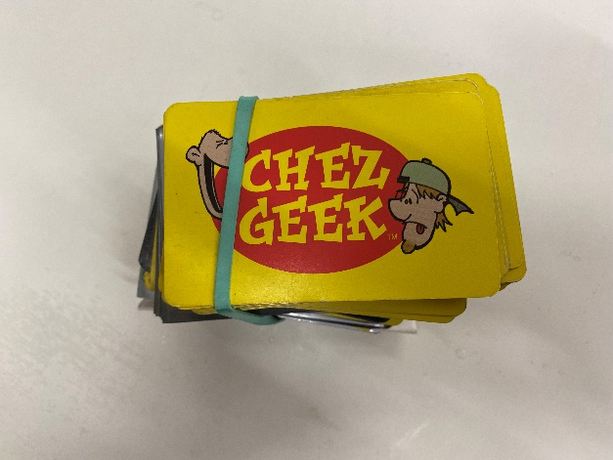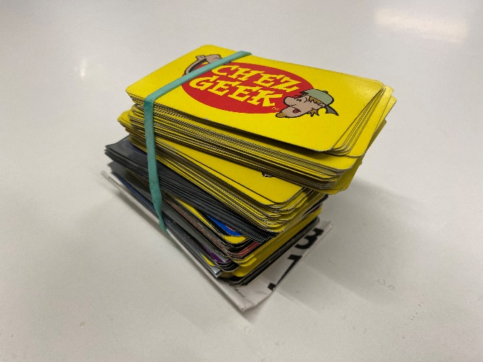

Settlers fra Catan – Supplementsæt for 5 og 6 spillere
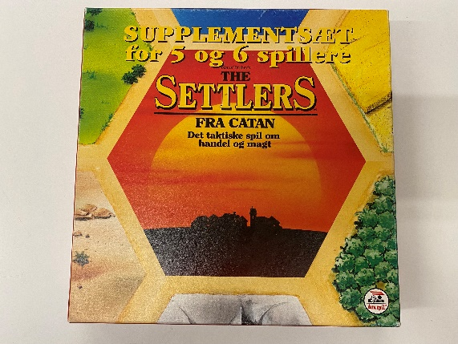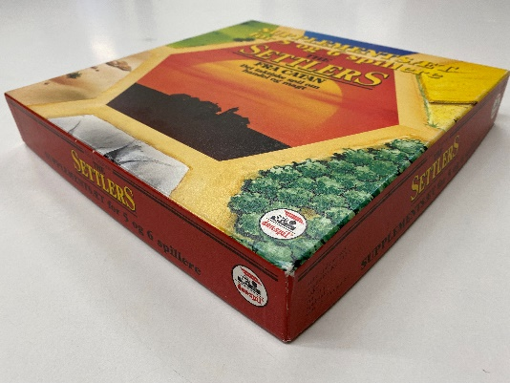

Betrayal at House on the Hill 2nd Edition
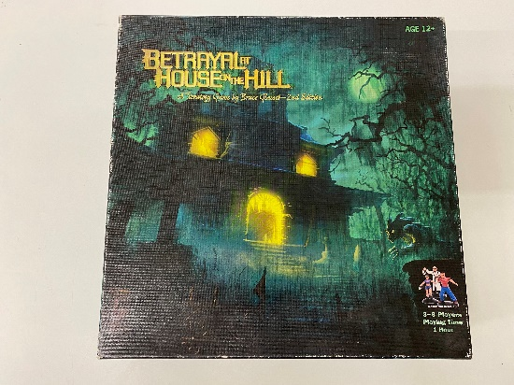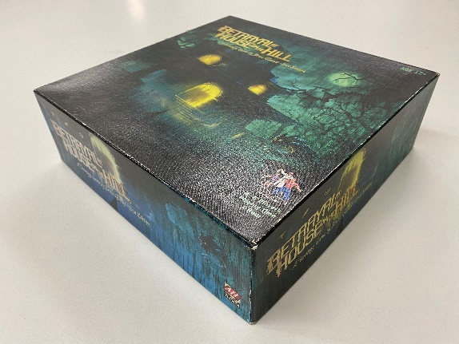

Betrayal at House on the Hill – Widow’s Walk
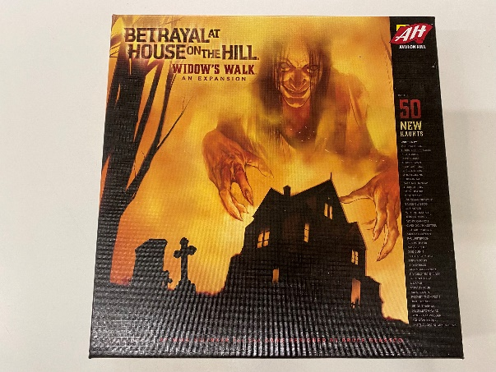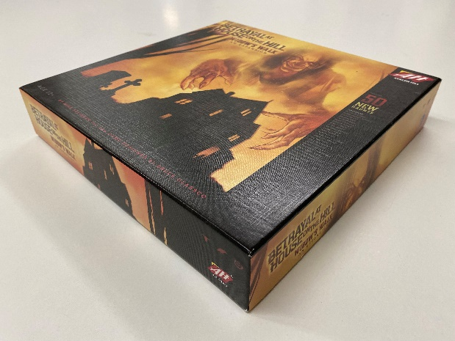

Kremlin
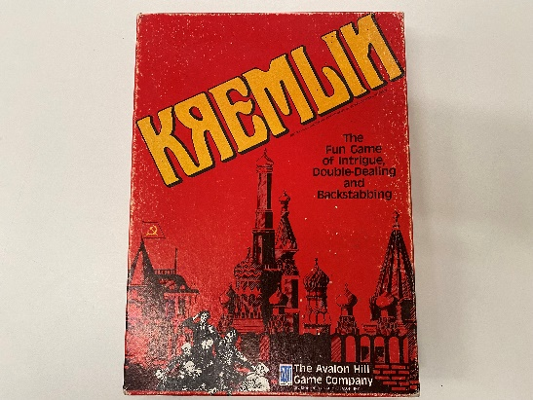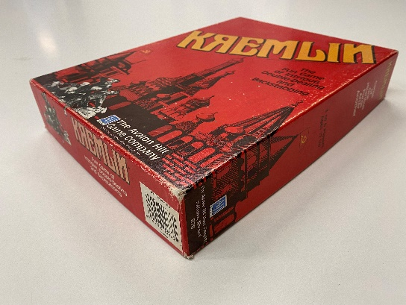

Blood Bowl Team Manager – The Card Game
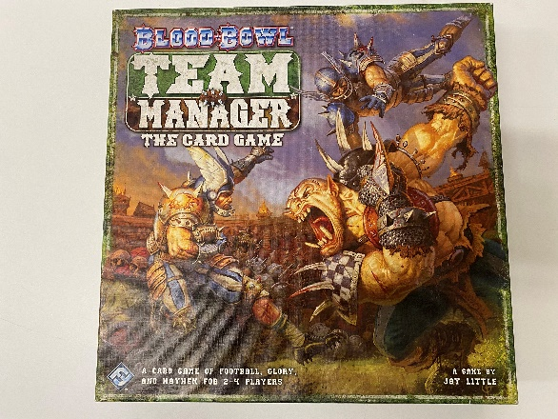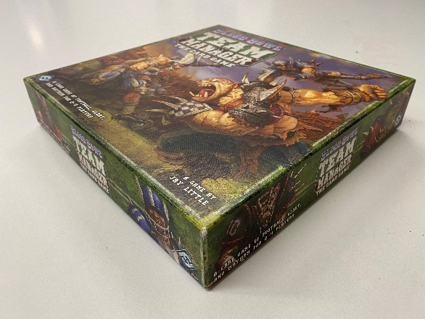

Battlestar Galactica – The Board Game (spil i udvidelseskasserne)

Battlestar Galactica – Pegasus Expansion
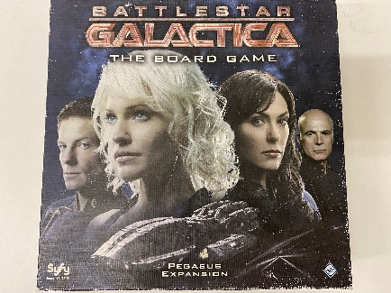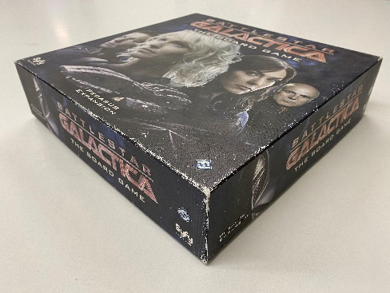

Battlestar Galactica – Daybreak Expansion
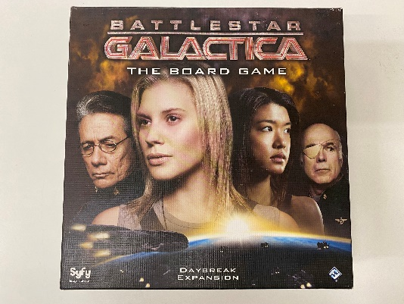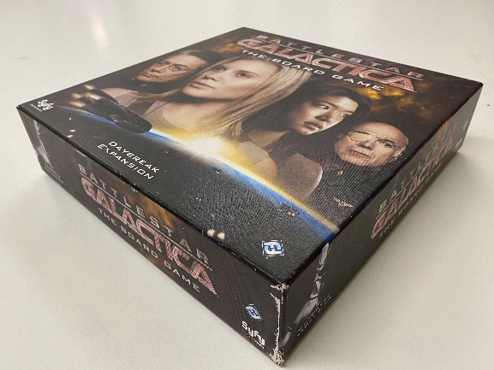

Battlestar Galactica – Exodus Expansion
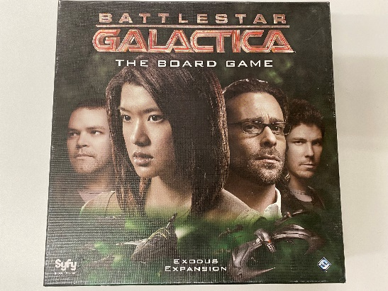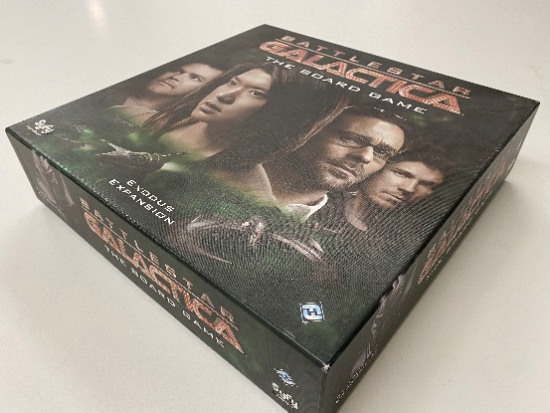

World of Warcraft – The Board Game
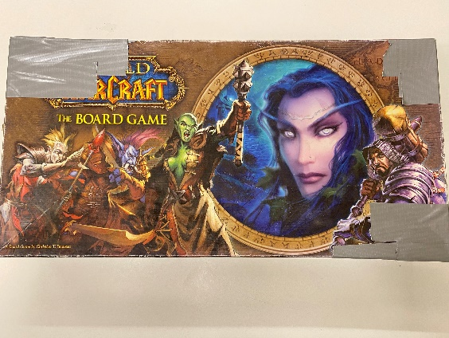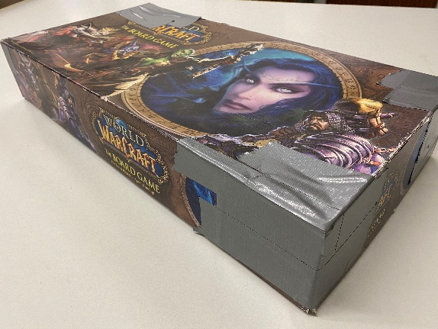

Backgammon
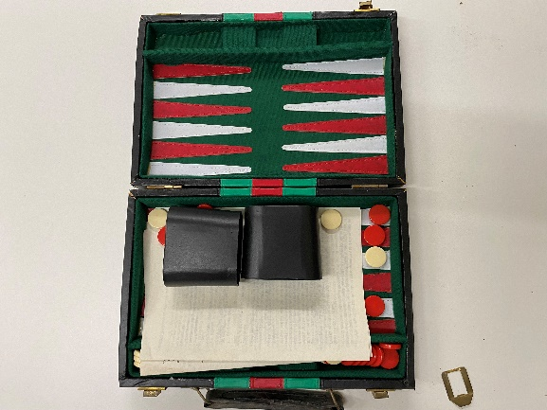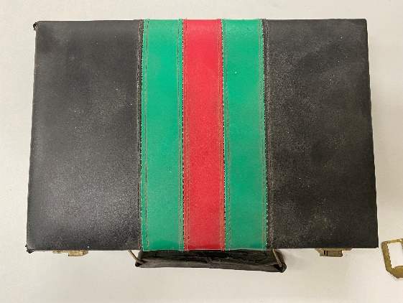

Star Wars Imperial Assault
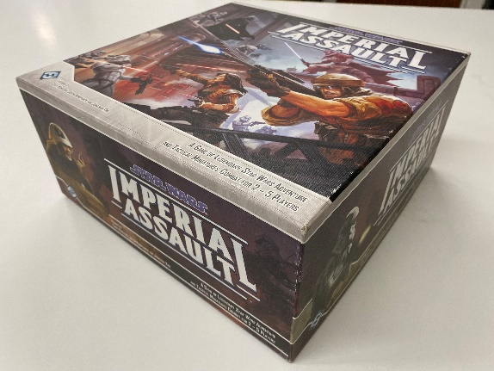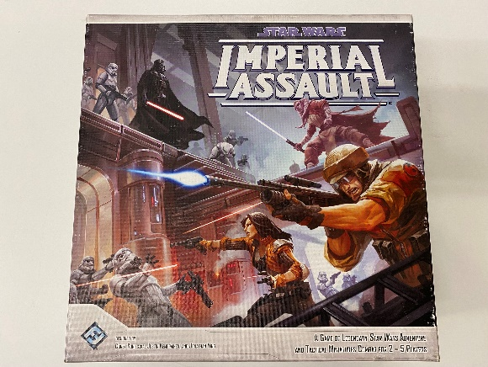

Star Wars Imperial Assault – Return to Hoth
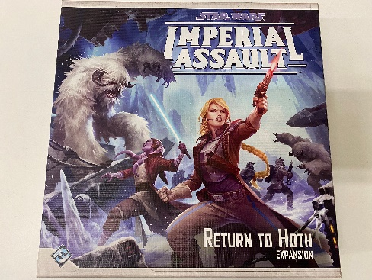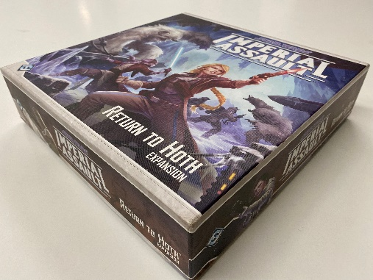

Star Wars Imperial Assault – Jabba’s Realm
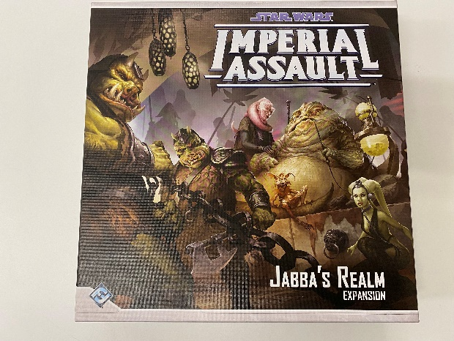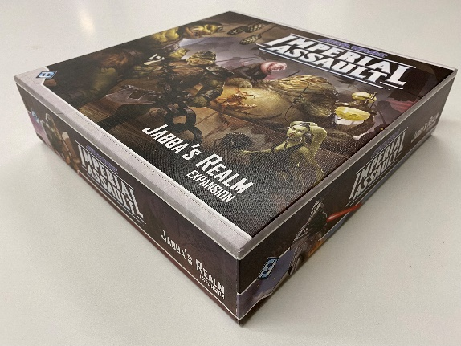

Star Wars Imperial Assault – Heart of the Empire
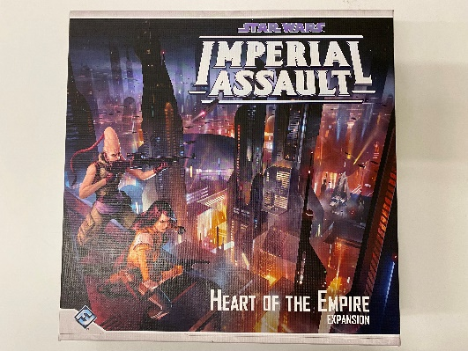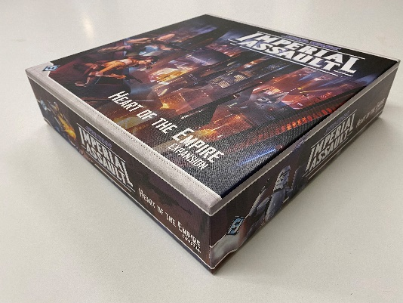

Star Wars Imperial Assault – The Bespin Gambit
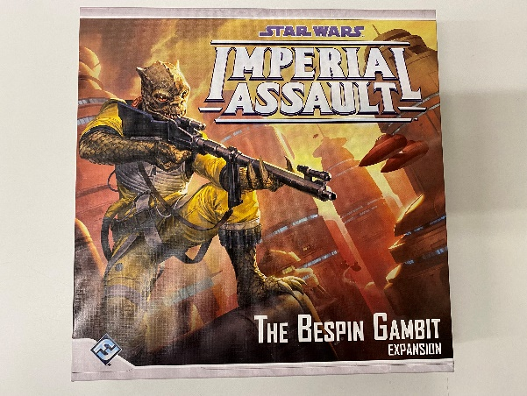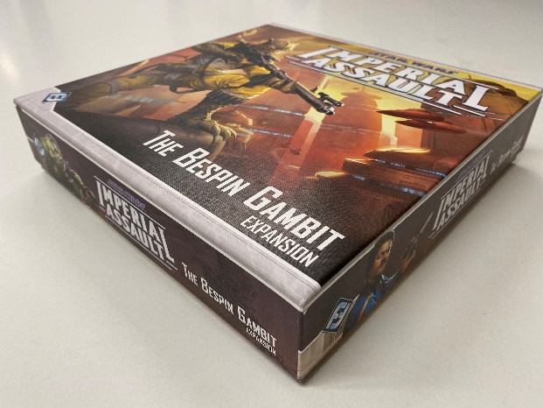

Star Wars Imperial Assault – Tyrants of Lothal
